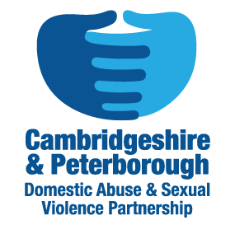
Cambridgeshire and Peterborough IDVA Service:
Good Referral and Bad Domestic Abuse Referrals
A Good Referral
- Details of all concerned persons (survivor, perpetrator and any children), including name, date of birth addresses, phone.

- Safe contact details

- Survivor’s language spoken and if interpreter is needed.

- Informed consent obtained.

- Abuse should be current or within 3 months of date of referring.

- Description of abuse suffered, detailed clearly and simply, reflecting the current government definition of domestic abuse.

- All mandatory fields of the online referral are completed.

- DASH risk assessment for high risk referrals

A Bad Referral
- No means of contacting the survivor safely.

- Lack of contextual information.

- Domestic abuse is historic (more than 3 months)

- Does not contain the relationship connection between survivor and perpetrator.

- No perpetrator’s details.

- No details of survivor’s needs and or disabilities.

- Contains jargon and acronyms.

- Illegible, poor spelling and grammar.

- Handwritten DASH

