Create an account on Our Development for external users
Step one
- Click on the link Registration - Enable (vc-enable.co.uk)
Step two
- Complete all sections of the form (please note – each user needs a unique email address)
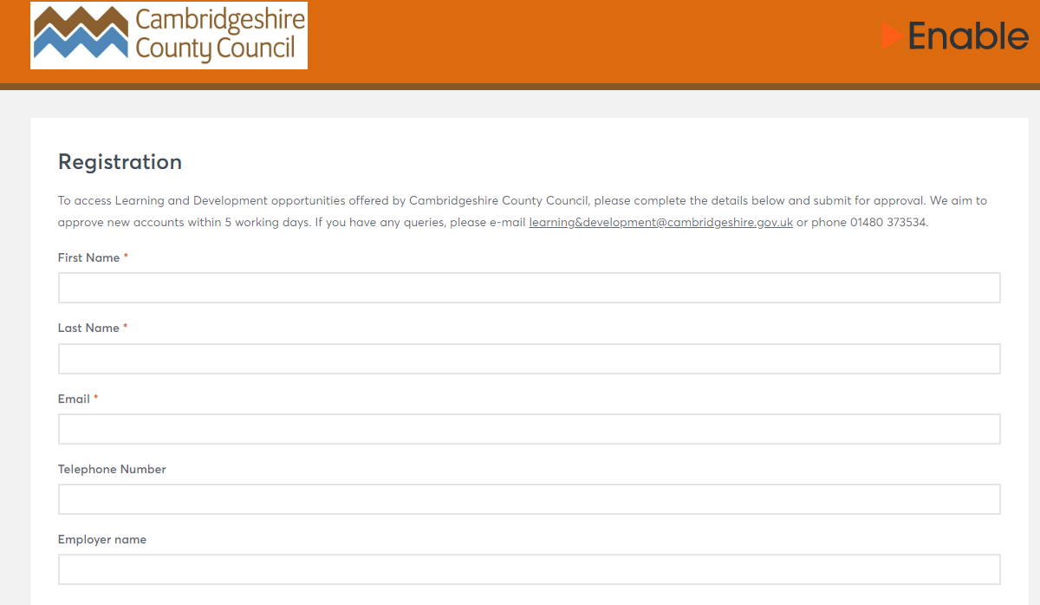
Step three
- Choose the group ‘DASV Champions’ then click register
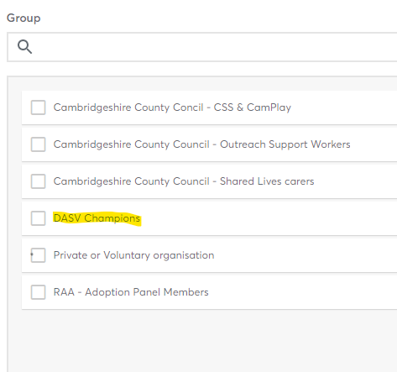

Step four
- Learning and Development will approve your account and you will be sent an email from Virtual College to set up a password

Booking on a session:
- To access the DASV Champion sessions, please click on ‘events’ on your dashboard followed by ‘all available events’
- This will bring up a list of available events for you to book onto. Click on the event that you are interested in and you will see a list of available dates
- Click on the date that you wish to attend and you will see the description of the session, click ‘join event’ to book your place
- You will automatically be booked on to the event. You will then be shown further details and options. This may include:
  - course resources for you to download,
  - the option to change the session you are booked on to
  - and to cancel your place.
Once your place is booked, it will move from ‘all available events’ to ‘my booked events’ on your dashboard. If you use Outlook you can click on ‘add to outlook calendar’ to generate an invite, otherwise you can join the event from your dashboard at your chosen time.
You will be sent email reminders before the event with any further guidance and instructions.

Support:
Should you have any difficulties in registering for an account or booking onto a session, please email: learning&development@cambridgeshire.gov.uk

