Older People and Domestic Abuse

Guidance for professionals

July 2021

Acknowledgement

This Guidance is based on a document developed by the Dewis Choice Project in April 2020
Amended for use in Cambridgeshire with kind permission

www.dewischoice.org.uk

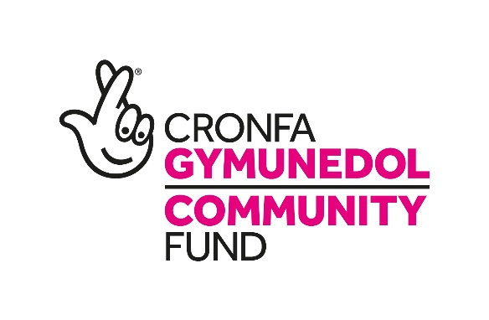

Who is this guidance for?

This guidance is for any professional working with older people, including volunteers.
Contents

Introduction 4

The Dewis Choice Initiative 4

1. What is Domestic violence and abuse? 5

1.1 Definition of domestic violence and abuse - England and Wales 5
1.2 Does domestic violence and abuse happen to older people? 6
1.3 Coercive control 7
1.4 Abuse from family members 9

2. Carers issues 11

2.1 Carer Stress 11
2.2 A change in behaviour due to brain conditions 10
2.3 Care or Control? 13
2.4 Signs to look out for 14

3. Response to domestic violence 15
3.1 Disclosures and asking about domestic abuse 15 3.2 Adult Safeguarding 16
3.3 Specialist Domestic Abuse Services 17
3.4 Assessing Risk 17
3.5 MARAC 18
3.6 A Coordinated Response 18

4. Justice Responses 18
4.1 Police Response 19
4.2 Civil options 20

5. Knowledge of rights and entitlements 21

6. LGBTQ+ Older People 22

7. Safety Planning 24

10.1 Individualised safety plan – guidance 24

8. Accommodation Options 27

9. Useful contact numbers 28

1. Introduction

This guidance was originally developed by research findings from the Dewis Choice initiative at the Centre for Age, Gender and Social Justice, Aberystwyth University. This version for use in Cambridgeshire and Peterborough aims to highlight specific issues relating to people who experience domestic violence and abuse (DVA) in later life and provide tools for practitioners to use when working with these victims/survivors.

This guidance is for the use of practitioners working in services who may come into contact with older people who experience DVA, including domestic abuse practitioners, practitioners working within criminal and civil justice, health and social care workers and anyone who would like to learn more about responding more effectively to older people who experience DVA.

The guidance has been amended for use in Cambridgeshire with kind permission from the Dewis Choice Project.

1.1 About the Dewis Choice Initiative

The Dewis Choice initiative was launched in Wales in 2015. Dewis Choice is a co-produced initiative consisting of a bespoke service designed by older people and a longitudinal research study, capturing the lived experiences of older people seeking help and justice.

Dewis Choice provides a dedicated ‘whole family’ service for women and men aged 60 years and over, who have experienced DVA from an intimate partner, ex-intimate partner and/or adult family member(s). Adopting an inclusive approach, the service also supports older lesbian, gay, bisexual, trans and queer or questioning (LGBTQ) clients, and cases where DVA and dementia co-exist.

Drawing on previous research findings within the United Kingdom, and developed by older people and a diverse range of professionals over a five-month period, the service element of the initiative aims to empower older victim-survivors to make informed choices about their justice options, be they civil, criminal and/or restorative. Co-production facilitated a design that is responsive to the needs of the community and compliments existing service provision.

The initiative is developed so that the service team can deliver intensive support for up to an 18-month period, to help clients recover from their abusive experiences and to promote their wellbeing. Thus, the service response includes crisis intervention and long-term intensive support that integrates prevention and recovery for older people. The service response works with older clients to improve their sense of wellbeing in the context of DVA.

The referral route into the Dewis Choice initiative is designed to be integrated into a coordinated community response.

1. What is Domestic Violence and Abuse?

1.1 Definition of domestic violence and abuse - England and Wales

Definition of “domestic abuse” 2021
(1)This section defines “domestic abuse” for the purposes of this Act.
(2)Behaviour of a person (“A”) towards another person (“B”) is “domestic abuse” if—
(a)A and B are each aged 16 or over and are personally connected to each other, and
(b)the behaviour is abusive.
(3)Behaviour is “abusive” if it consists of any of the following—
(a)physical or sexual abuse;
(b)violent or threatening behaviour;
(c)controlling or coercive behaviour;
(d)economic abuse (see subsection (4));
(e)psychological, emotional or other abuse;
and it does not matter whether the behaviour consists of a single incident or a course of conduct.
(4)“Economic abuse” means any behaviour that has a substantial adverse effect on B’s ability to—
(a)acquire, use or maintain money or other property, or
(b)obtain goods or services.
(5)For the purposes of this Act A’s behaviour may be behaviour “towards” B despite the fact that it consists of conduct directed at another person (for example, B’s child).
(6)References in this Act to being abusive towards another person are to be read in accordance with this section.
(7)For the meaning of “personally connected”, see section 2.

2. Definition of “personally connected”
(1)For the purposes of this Act, two people are “personally connected” to each other if any of the following applies—
(a)they are, or have been, married to each other;
(b)they are, or have been, civil partners of each other;
(c)they have agreed to marry one another (whether or not the agreement has been terminated);
(d)they have entered into a civil partnership agreement (whether or not the agreement has been terminated);
(e)they are, or have been, in an intimate personal relationship with each other;
(f)they each have, or there has been a time when they each have had, a parental relationship in relation to the same child (see subsection (2));
(g)they are relatives.
(2)For the purposes of subsection (1)(f) a person has a parental relationship in relation to a child if—
(a)the person is a parent of the child, or
(b)the person has parental responsibility for the child.
(3)In this section—
- “child” means a person under the age of 18 years;
- “civil partnership agreement” has the meaning given by section 73 of the Civil Partnership Act 2004;
- “parental responsibility” has the same meaning as in the Children Act 1989 (see section 3 of that Act);
- “relative” has the meaning given by section 63(1) of the Family Law Act 1996.

3. Children as victims of domestic abuse
(1)This section applies where behaviour of a person (“A”) towards another person (“B”) is domestic abuse.
(2)Any reference in this Act to a victim of domestic abuse includes a reference to a child who—
(a)sees or hears, or experiences the effects of, the abuse, and
(b)is related to A or B.
(3)A child is related to a person for the purposes of subsection (2) if—
(a)the person is a parent of, or has parental responsibility for, the child, or
(b)the child and the person are relatives.
(4)In this section—
- “child” means a person under the age of 18 years;
- “parental responsibility” has the same meaning as in the Children Act 1989 (see section 3 of that Act);
- “relative” has the meaning given by section 63(1) of the Family Law Act 1996.

1.2 Does domestic violence and abuse happen to older people?

The Home Office definition of DVA refers to all those aged 16 years and over. Across widespread media and marketing materials DVA has been portrayed as an issue mainly affecting heterosexual, white women under the age of 60 years who have children. Resources for victim-survivors prioritise younger women, and their children, who are experiencing violence and abuse from a male partner or ex-partner.

Service provision, risk assessment tools and resources are designed to assess risk in intimate partner violence, not adult family abuse and violence; despite, the Home Office definition of DVA including family members/relatives. The national organisation ‘SafeLives’, which focuses on DVA victimisation, highlights that in 2016, people aged 61 years and over were more likely to experience abuse from an adult family member, than a current intimate partner. Research to date by Dewis Choice, has found that often statutory service providers do not recognise DVA in cases where the perpetrator is not an intimate partner; as a result, older victim-survivors are often not offered access to specialist domestic abuse resources.

Research design also highlights an inbuilt ageism, for example, until 2017 the Crime Survey for England and Wales only collected data on DVA for those aged 16 to 59 years. The age limit has now increased to include those aged 60 to 74 years and the age limit will be removed from 2021, but it will take several years for comparable data to build up.

There is significant evidence to show that older people are as likely to experience all forms of DVA as

their younger counterparts are, but less likely to report it. Research from Dewis Choice suggests that older people do not feel that current services cater for them, especially given the imagery and text used in advertising does not represents a diverse group of age-ranges and needs.

1.3 Coercive control

Coercive control is often a feature in older people experiencing abuse from an intimate partner but also occurs in abuse from adult family members. However, awareness raising campaigns on the introduction of the new offence focused primarily on heterosexual younger people in intimate partner relationships, rather than highlighting coercive or controlling behaviour across the life course that can be perpetrated both by men and women, and occur within all familial relationships.

An older person may have experienced coercive control for decades in an intimate relationship, significantly influencing their sense of self-identity and confidence in their ability to make decisions for themselves.

Perpetrators who use coercive and controlling behaviours can affect all areas of an individual’s life. Perpetrators often target aspects of the person’s identity where it will achieve maximum impact on the person’s sense of self. For an older person, age-related factors such as, health conditions, disability, care needs and levels of social contact can be manipulated by an abusive partner and/or family member to increase their control and the victim-survivor’s dependency on them. Where the threat of physical violence is a feature, levels of fear can increase with age as an individual becomes aware they are less able to withstand a physical assault.

Ageist stereotypes of ageing can mask coercive control, for example, withdrawing from social contact is misconstrued as a natural sign of ageing. Abusive tactics can include ‘gas-lighting’, a term used to describe perpetrators manipulating the older person by psychological means to doubt their own sanity and mental capacity. Perpetrators seek to encourage practitioners to also question an older person’s mental capacity to gain greater control over the older person's decision-making, which may lead to practitioners not recognising signs of coercive control.

A diagnosis of dementia can be used to further abuse and control, through questioning an individual’s account of experiences and enforcing fears that they will not be believed if they disclose DVA. A partner or family member can abuse their position as carer for the older person, speaking on their behalf, undermining the older person’s confidence and restricting the older person’s time alone with practitioners.

The Duluth Power and Control Wheel was originally created by Ellen Pence and Michael Paymar as a tool to help explain the variety of ways perpetrators use power and control manipulate and abuse that may not be physical in nature. Dewis Choice have adapted the Duluth Wheel based on their research examining the lived experiences of over 90 older victim-survivors that engaged with the Dewis Choice Initiative.

©2020 Dewis Choice. All Rights Reserved

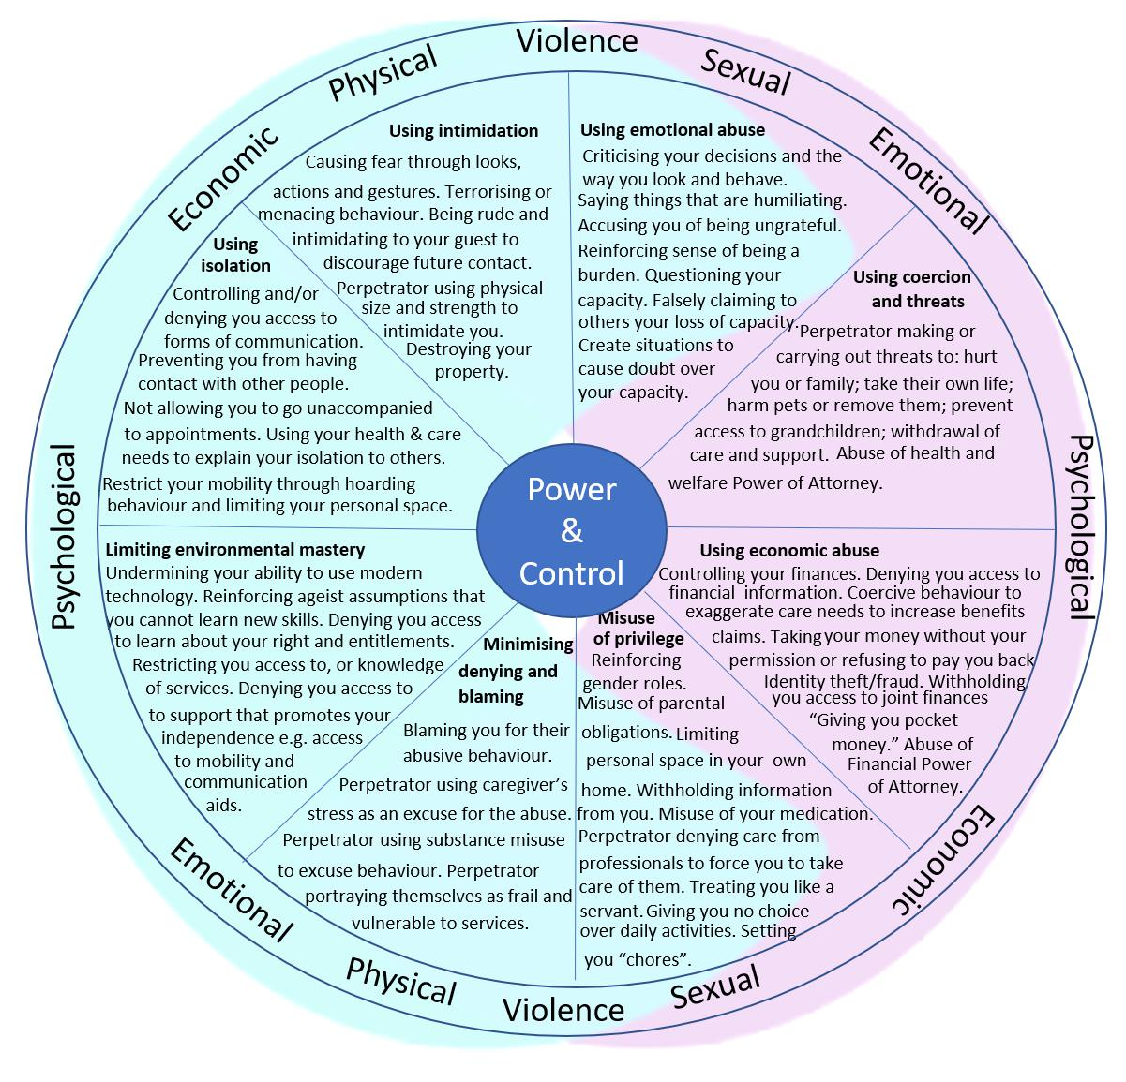

1.4 Abuse from family members

Research undertaken by the Centre for Age, Gender and Social Justice has found that often service providers do not recognise DVA in cases where the perpetrator is not an intimate partner; as a result, victim‐survivors are not offered access to specialist domestic abuse resources.

An older person can experience DVA from an adult son or daughter or adult grandchild who may, or may not, be living in the same home. DVA from an adult child or grandchild can include similar types of abusive behaviours as intimate partner relationship including: physical, emotional, financial, economic, psychological, sexual abuse, and coercive or controlling behaviour.

In cases of adult family violence and abuse, an older victim‐ survivor may depend on the abuser, for example for help with personal care, financial help or errands – see Carer section p.11. Equally, the abuser may depend on the victim/survivor. It should also be noted that a victim/survivor may be experiencing abuse from multiple family members.

How DVA can socially isolate an older person

Victims-survivors of DVA are often socially isolated and have limited individuals in their social network who can offer support. Perpetrators can act to restrict and closely monitor the social interactions of the individual to prevent them from being able to disclose and seek help for the DVA they are experiencing. Older individuals who have experienced long-term DVA from an intimate partner may have become isolated from family members, including parents and siblings, over decades. The abusive behaviours of the perpetrator may have prevented the victim-survivor from forming close friendships

Questions to consider are:

- Has someone, who was previous socially connected and took part in activities, stopped seeing friends or going to community clubs? If so, what has changed in the individual’s life? Has their partner retired, or a family member moved in with them?

- Has an older person started to miss appointments or, does someone always accompany them when they attend appointments?

- Has an older person suddenly stopped inviting visitors to their home?

- If an older person has always been socially isolated, was this their choice and do they want things to change?

1.5 Ignored, invisible and overlooked - Older people as victim-survivors of domestic violence and abuse

As noted previously, older people are rarely portrayed in the media as victim-survivors of DVA. Awareness raising campaigns have traditionally been targeted at young white women, often with small children, experiencing physical violence perpetrated by a current intimate partner.

As a result:

- Domestic abuse service provision has not been designed with the needs of older victim-survivors of DVA in mind;

- Older women and men may not identify themselves as victim-survivors of DVA which creates an additional barrier to accessing support;

- Practitioners may not identify older people as victim-survivors of DVA, therefore may not offer support and access to the domestic abuse services and resources available as they do with younger people;

- Service providers may not understand how to engage with, and support older people who experience DVA;

- DVA perpetrated by a family member, for example, an adult child or grandchild, sister or brother, may not be recognised as domestic abuse, especially where there is a co-existence of dementia and DVA.

The diagram below highlights the key institutional and organisational barriers older people when seeking help and justice based on research by Dewis Choice.

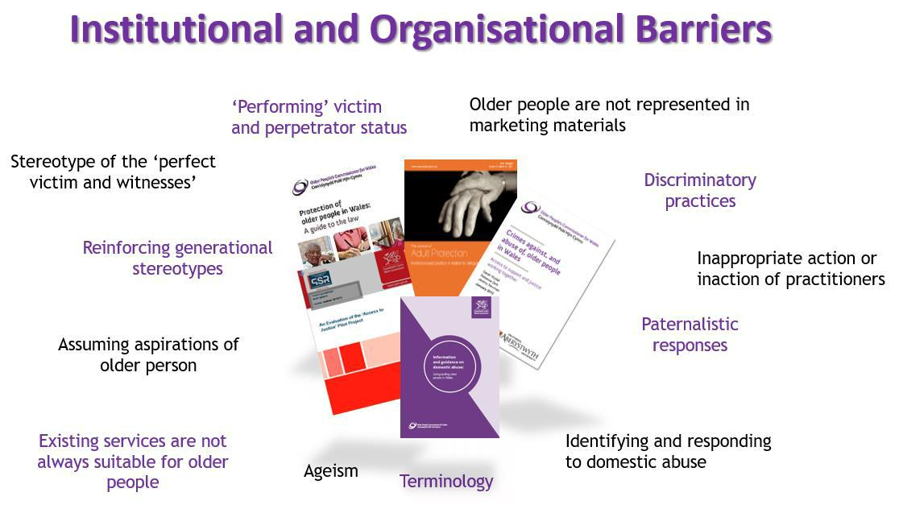

2.0 Carer Issues

2.1 Intimate partner/adult family member – Carer-giver stress

In some cases, partners and family members can unintentionally harm those they care for, due to a lack of understanding of the care needs of an individual, or through an inability to cope with providing care. Even when abuse is unintentional, it can still have a considerable and lasting impact on the older individual in terms of unmet needs, physical and emotional harm and distress. Where genuine care‐giver stress occurs, additional support and respite may help resolve the situation.

Practitioners should never presume harm caused by a care‐giver is unintentional and always explore the possibility that the relationship may have always been coercive, controlling and abusive.

Anyone providing care to a family member/relative in Cambridgeshire is entitled to a Carers Assessment. It is important that the person carrying out the Carers Assessment considers the possibility of disguised compliance and the impact on the cared for person of what the carer is saying about their situation and feelings.

2.2 change in behaviour due to a brain condition

A relationship that was once positive can dramatically alter when a partner or family member develops a condition affecting their brain. Dementia, caused by diseases of the brain, can create changes in a person’s mood and behaviour leading to verbal or physical aggression. In this instance, the causal nature of the abuse is different, even though the behaviours may present as DVA. It is important to understand the complexity of the care dynamic in this instance and be aware that the target of the abuse, the older person, may be more tolerant of the behaviour because it is viewed as unintentional, which places them at a greater risk than they might if they felt the behaviour was intentional.

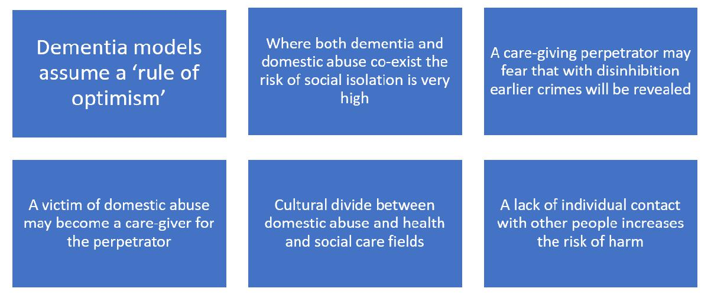
Findings from Dewis Choice show that when victim-survivors of abuse become a care-giver for a perpetrator who has dementia, the risk of harm increases significantly. The close proximity of the harmer to the victim-survivor makes it harder for them to keep themselves safe, given prolonged periods spent with the perpetrator providing daily care. Unfortunately, limited attention is given to the co-existence of dementia and DVA by policy-makers; this had led to an inadequate service response. Current service responses tend to concentrate on the dementia rather than a holistic approach to the person’s needs.

Practitioner considerations:

When you suspect that the older person with dementia is experiencing DVA ensure that you:

- Create a safe space for the older person to interact with service providers on their own, away from their intimate partner or family members;

- If the person with dementia has difficulty communicating ensure they are assisted to express their needs, using simplified language and communication aids;

- Do not dismiss what the person is telling you as confusion related to dementia. They may have difficulty clearly explaining a full account of events, but it is important to take what they are saying seriously, explore further and log concerns;

- Do not assume someone lacks capacity because they have a diagnosis of dementia, or a family member tells you they lack capacity;

- If there is an assessment of a lack of capacity ensure you check in what areas the person lacks capacity to make decisions;

- Where the person with dementia is assessed as having a lack of capacity consider the use of an independent advocate, who is not their partner or family member;

- Ask if the person with dementia has designated someone with power of attorney. If so, is this the person they are experiencing abuse from?;

- If the person with dementia has full capacity explore their options to designate power of attorney to a person they identify as safe;

- When a person states they are designated with power of attorney for a person with dementia ask to see a copy;

- Explore safety planning (see safety plan).

When the older person is experiencing abuse from a person with dementia:

- Create a safe space for the older person to interact with service providers on their own, away from the person with dementia they are living with and/or caring for;

- Encourage honest and open discussions about whether the older person wants, or feels able to, provide care for the person with dementia;

- Do not assume abuse is a new feature of the relationship caused by dementia. Ask about the behaviour of the person with dementia towards the older person before they developed dementia;

- Reassure that it is alright to seek help and support and encourage them to do so;

- Ask if the older person wants support to leave the relationship;

- Explore safety planning (see Safety Planning p.24).

2.3 Care or Control?

Practitioners coming into contact with older individuals in receipt of care by partners and family members may find it difficult to identify the difference between care and control. The Older People’s Commissioner for Wales refers to practitioners adopting a ‘rule of optimism’, assuming partners and family members providing care for an older person have good intentions. The ‘rule of optimism’ can lead to practitioners failing to recognise signs of abuse, mistakenly attributing them to declining health and mobility, reinforcing abusive behaviours and leaving an older person at increased risk of further abuse

When domestic violence and abuse (DVA) exists in a relationship, increased dependency on the abuser can be manipulated to exert control over the older person and further isolate them from sources of external support.

Care and support needs can place an older person in a position of dependency if they are reliant on their family member to meet their care needs. If the care and support is a new feature in the relationship for example, an adult child or grandchild becomes the carer for the first time, this can lead to a shift in power dynamics in the relationship. A family member may move into the older person’s home or the older person may move in with family, marking a significant loss of independence and autonomy.

It is important to recognise that family carers may be providing assistance with things other than personal care – this could include support to take medication, help with organising finances or household bills or running errands such as shopping.

An older person can also find themselves in the position of primary carer for a partner or family member who is abusive towards them. Providing care can bring the older person into close physical contact with a person who is physically abusive towards them and past coping strategies to minimise the risk of harm may no longer be effective. Caring responsibilities can lead to increased isolation, with the older person feeling they cannot longer leave the home to pursue activities they enjoy that provide respite from the abuse.

In situations where the perpetrator is an intimate partner, increasing care needs and dependency on the victim-survivor can mark a shift in the relationship and a fear of a loss of control for the perpetrator, which may mark an increase in coercively controlling behaviour.

Adult family members may use their position as a carer to financially abuse the older person, by taking control of their finances, denying them access to bank statements and debit cards.

Financial abuse can also take the form of a perpetrator exaggerating the older person’s care needs so they receive additional benefits. Clients engaging with support from Dewis Choice explained how they had felt ashamed after being coerced by family members to keep quiet and pretend they could not carry out routine tasks during care and benefit assessments.

2.4 Signs to look out for

There may be no visible physical signs of abuse, particularly abuse which is emotional and controlling in nature, which can include:

- refusing to support the older person’s independence, creating increased dependency on the carer;

- exaggerating the older person’s mobility or health issues to explain why they are not engaging socially;

- exaggerating the older person’s care needs to practitioner’s, other family members and friends;

- denying access to mobility, hearing and visual aids;

- telling others that the older person lacks capacity to make decisions for themselves;

- threatening to withdraw care if the older person does not comply with their wishes;

- verbally demeaning the older person and making them feel ashamed or like a burden;

- refusing to transport, or allow others to transport the older person to visit friends, attend social activities or appointments;

- making visitors to the older person’s home feel uncomfortable;

- taking control of the older person’s means of contacting friends and services, for example, not allowing them to answer the phone, opening their post, denying access to digital technology.

Partners and family members in caring roles may speak on behalf of the individual and the voice of the older person can become lost. For an individual who is experiencing abuse from a partner or family member who is also their carer, time spent alone with a practitioner may be the only opportunity they have to disclose what is happening to them. Therefore, it is extremely important for practitioners to create a safe space away from partners and family members and to let the older person know they are a safe person to talk to about anything that is troubling them. It is also important to recognise that the person may be reluctant to disclose the abuse for fear of getting their family member into trouble, or fear of what might happen to themselves if they speak out – this could be fear of reprisals from the abuser but also fears that they might have to leave their home or change care arrangements.

3.0 Responses to Domestic Violence and Abuse

3.1 Asking about or responding to a disclosure of domestic abuse

- Never ask when the perpetrator/suspected perpetrator is present
- Don’t use family members as interpreters
- Ensure confidential environment
- Actively listen, believe, reassure, don’t criticise
- Listen to what the victim wants – don’t try to take control & don’t make assumptions
- Explain what you will do next

Suggested questions:

- Is it safe to talk?
- Are you safe to go home?
- Are you frightened of your partner?
- How are things at home?
- Do you manage or cope at home?
- Do you feel free to ask questions and make decisions together?

Practitioner considerations:

- Reassure the older person you are a safe person to talk to and you will not share information without their consent, but you have a duty to share information if someone is identified as at risk of serious harm;

- Show an interest in the individual’s story, giving them your full attention;

- Move at the pace of the individual and avoid interrupting unless it is to clarify or confirm key information;

- Reflect back to the older person what they have said, demonstrating your understanding and clarifying it is correct;

- Respond using the language the older person is comfortable with;

- Avoid using language and terms that could be misinterpreted or misunderstood;

- Affirm that the older person has a right to feel upset, distressed, afraid and angry and be comfortable with them expressing their emotions;

- Build a relationship and trust before exploring difficult and painful experiences.

3.2 When an older person experiences domestic violence and abuse, is it always an Adult Safeguarding issue?

Adult safeguarding means protecting a person’s right to live in safety, free from abuse and neglect. Safeguarding processes should protect the health, wellbeing and rights of an adult at risk, supporting the individual to exercise choice and control over how they want to live. Safeguarding procedures involve practitioners providing accessible information, advice and support to adults at risk about how to stay safe and how to raise a concern.

Local Authorities in England, Wales and Scotland have a duty to act to safeguard an adult who meets the criteria of an “Adult at risk.”

Adults at risk

The definition of an “Adult at risk” for each country, is contained in The Care Act 2014. The Care Act provides a legal framework for improving the wellbeing of people who have care and support needs and look specifically at safeguarding.

An adult at risk is an adult who:

- has needs for care and support (whether or not the local authority is meeting any of those needs);

- is experiencing, or is at risk of, abuse neglect; and

- as a result of those needs is unable to protect himself or herself against the abuse or neglect or the risk of it.

Under section 42 of the Care Act (England) 2014,⁷¹ where a local authority has reasonable cause to suspect that an adult in its area is an adult at risk, the local authority must make (or cause to be made) whatever enquiries it thinks necessary to enable it to decide whether any action should be taken in the adult’s case and, if so, what and by whom.

A person may, or may not, meet the criteria for an Adult Safeguarding response, depending on their circumstances (see Adult Safeguarding section). Even when an older person does meet the criteria for an Adult safeguarding response they can choose to refuse one (but refusing consent should not precent the practitioner from taking further advice). An older person in receipt of support from local authority Adult Safeguarding for DVA can still benefit from, and should be offered access to, specialist domestic abuse support and resources, regardless of their age.

To make an Adult Safeguarding Referral please visit Concerned? | Cambridgeshire and Peterborough Safeguarding Partnership Board (safeguardingcambspeterborough.org.uk)

3.3 Specialist domestic abuse Services

Cambridgeshire response

The Independent Domestic Abuse Advisory Service (IDVAS) operates across Cambridgeshire and Peterborough to support high risk victims of domestic abuse. In addition, there are specialist ‘Health IDVA’s who work closely with hospital services across the county and who support victims at all risk levels. Referral to the IDVAS is by professional referral only.

The IDVA Service work closely with agencies such as Health, social care and police and are keen to work in partnership with other agencies where the case is complex and this approach is often used for older victims/survivors.

Additionally, Outreach Support is available that victims/survivors are able to self-refer to. Outreach can work with survivors on a longer term basis with a focus on recovery.

A professional referral can be made to the IDVA Service (dependent on risk – see section 3.4) or the person can self-refer to Domestic Abuse Outreach Services (see section 3). However, it is important to consider the needs of the person with either referral route, for example, do they need assistance with communication or would they need help to make the initial contact with Outreach Services. In addition, the practitioner working closely with the person may need to consider options for the IDVA or Outreach Service to meet with them safely – can the DA service do a joint visit with another service, is there an opportunity to meet the person at day care or at a GP surgery?

3.4 Assessing Risk

Risk assessment is key to safety planning. The Domestic Abuse, Stalking and Harassment and Honour-Based Violence Risk Identification Checklist (DASH RIC)¹⁹ tool aids specialist safety planning and enables assessors to discuss with clients the involvement of specialist advocates.

However, practitioners working with older people widely acknowledge that the DASH RIC doesn’t work as well where the victim is an older person as many of the questions relate to pregnancy and children. This often results in the risk score being low, so escalation is then based upon the individual professional judgement of the practitioner, which can be subjective depending on their own knowledge of the subject.

In Cambridgeshire, we are piloting an Older People’s DASH from between August 2021 and February 2022 (6 month period). The OP DASH has replaced some of the less relevant questions with those around care and support needs, carer abuse and coercive control.

The OP DASH can be downloaded from *****

3.5 Multi-Agency Risk Assessment Conference (MARAC)

Multi-Agency Risk Assessment Conferences (MARAC’s) are multi-agency meetings, attended by representatives from local statutory and voluntary agencies who regularly come into contact with victim-survivors of DVA, their children and perpetrators. MARAC’s are held three times a week in Cambridgeshire and information is shared across organisations, with the aim to better protect victim-survivors from DVA.

Based on the information shared at a MARAC, the representatives will form a plan of actions tailored to reduce the risks identified to the victim-survivor and their children were applicable. Data from SafeLives
from 2018-2019, found only 3% of those accessing IDVA services and supported by the MARAC model, were over 60 years of age.

3.6 A Coordinated Response

Coordinated community responses are crucial for all older victims-survivors of DVA whether they are deemed at high-risk, for example, through the MARAC model above, or at standard risk and as an early intervention, through a range of agencies. Older people engaging with support from Dewis Choice benefitted from a coordinated community response involving a variety of agencies including adult safeguarding, health, mental health, housing, occupational therapy and specialist services that support older people.

In Cambridgeshire we work closely with the agencies listed above and the IDVA Service can offer to instigate or join multi-agency meetings outside of the MARAC process where a case is complex. This allows all involved organisations to consider the best way to keep the person safe even where the standard MARAC route isn’t appropriate.

4.0 Justice Responses

Justice options for individuals who experience DVA, include criminal, civil and restorative processes, all of which are not mutually exclusive interventions, but can complement each other depending on the stage the older person is at in their help-seeking journey. Research from the Dewis Choice Initiative found that individuals sense justice through 1) accessing knowledge about their entitlements and rights,
2) continual validation of their experiences, and 3) positive support from family, friends and the community.

Criminal routes can involve a prosecution against a perpetrator for DVA-related crime. There are also a range of criminal and civil options designed to provide protection against further abuse (see protection orders). Securing individual rights can also provide a sense of justice, for example, removing an abusive ex-partner from a joint tenancy, pursuing a divorce (see Divorce) and securing access to jointly held assets.

As with younger age groups, older people’s perception about criminal processes are based on media portrayals. Practitioners can help demystify the process and be there to support and guide the older person through their justice-seeking journey. Writing down and talking through the steps in the court process helps to allay some of the fears associated with this process. The use of language needs to be accessible and a starting point for practitioners should be to assume the older person has no prior knowledge of justice processes.

An older person who has experienced DVA from a family member, particularly from an adult child or grandchild, can be reluctant to report to the police or support police action to impose a criminal sanction. There can be a fear of the consequences associated with a criminal sanction including, increased risks to safety, fear of the abuse becoming public, and fear of negative responses from other family members. They may also want to help the abuser, for example, with financial or substance misuse issues.

However, practitioners should never assume the older person will not want to pursue a criminal sanction and should explore the reasons for any reluctance. It is also worth noting that time away from the abuse may lead to the victim/survivor reconsidering a criminal justice route even if they declined it in the past.

4.1 Domestic violence and abuse – Police response

Individuals should be reassured they can call 999 in an emergency or 101 in a non-emergency, alternatively they can attend a police station in person to report an incident.

Cambridgeshire Constabulary have officers who are specially trained to deal with DVA.

DVA from an intimate partner, ex-partner, or adult family member should be treated as seriously as an action by a stranger, for example, an assault, threat or theft. All police officers can use their powers to intervene, arrest, caution or charge a perpetrator. Suspects may be remanded, kept in custody or may be given bail before being charged, depending on the nature of the incident reported.

Domestic Violence Protection Notices and Orders – England and Wales

In England and Wales, the police now have powers to serve a Domestic Violence Protection Notice (DVPN) on a perpetrator who presents an ongoing risk of violence. This notice is provided in writing and served to the perpetrator by a police officer.

The order lasts for 48-hours and requires the perpetrator to leave the premises and not contact the victim-survivor, either directly or indirectly. The order can be extended further (up to 28 days) by a magistrate at court, who can grant a Domestic Violence Protection Order (DVPO).

DVPO’s promote the immediate safety of a victim-survivor of DVA by removing the perpetrator. Along with orders of longer duration, such as restraining order and non-molestation orders (see below), DVPO’s can also provide a victim-survivor of DVA with time and space away from the perpetrator to consider all of the options available to them.

4.2 Civil Options

Civil option issued by criminal courts- Restraining order

In the UK, when an individual is convicted or acquitted of an offence involving DVA, the court can issue the person who has had criminal proceedings against them with a restraining order. Restraining orders seek to protect a victim-survivor from further abuse by imposing restrictions on a perpetrator (a partner, ex-partner or family member) from contacting a victim-survivor. A restraining order can be imposed for a set period of time or indefinitely. Breach of the conditions in a restraining order is an arrestable offence.

Civil options issued by family courts

There are a range of civil options an individual can access to seek protection for themselves, and to secure their rights to property and finances. Civil options are applied for through the courts system, however they do not involve any criminal proceedings.

The following civil options can be accessed by individuals either representing themselves or through a solicitor. Most family law solicitors offer a free half hour confidential initial consultation to discuss options and explain any costs involved. Individuals should ask for this service when making an appointment. Domestic abuse services can support individuals accessing civil options and help with making an appointment with a solicitor.

Civil protection orders

Victim-survivors of DVA can apply to family courts for a civil injunction or court order to help protect them. Civil protection orders can be applied to an intimate partner, ex-intimate partner or a family member, for example, an adult child, grandchild, brother or sister. The most common types of court orders are:

Non-molestation orders are similar to a restraining order but can also be obtained by individuals seeking to protect themselves where there are no criminal proceedings against the perpetrator. A non-molestation order is aimed at preventing the perpetrator, from using or threatening violence against a person, or intimidating, harassing or pestering them. It can also prevent the perpetrator from entering a location within a certain distance of their home. Each order is unique and will take an individual’s circumstances into consideration. When making the order,

the magistrates will take into account a person’s health, safety and well-being. The magistrates will also assess how they think an order will help the situation. As with a restraining order, it is a criminal offence if the non-molestation order is broken and a person can call the police to report this.

Occupation orders state who can live in a property and are often applied for at the same time as a non-molestation order but can be applied for separately. Similar to non-molestation orders, they are tailored to a person’s individual circumstances. The order could state that the perpetrator must leave the property where the victim-survivor resides. It can also prevent the perpetrator from coming within a certain area, such as 200 yards, of a person’s home. If an occupation order is breached, the person will be in contempt of court and a judge can impose a fine or imprisonment for breaking the terms of the order.

Undertakings can be used when the victim-survivor does not wish for there to be a criminal offence following a breach of the order. The undertaking is a legally binding promise made to the court to take a specified action, or refrain from taking an action, in the future i.e. not to have contact with the victim-survivor. The undertaking should be recorded in writing and a signed copy should be filed with the court. If the promise is broken, it can be punished with a fine or imprisonment, but the respondent cannot be arrested immediately following a breach.

Divorce – A person can apply for a divorce online or by post through a solicitor if a marriage has broken down irretrievably. The grounds for divorce can be adultery, abandonment, unreasonable behaviour including DVA, separation lasting two years or more (with both parties consenting), separation lasting five years or more (even if one party does not consent).

5. Knowledge of rights and entitlements

When supporting an older person experiencing domestic violence and abuse (DVA), it is important to be mindful that older people are often not aware of individual rights and entitlements to access resources, such as housing rights, benefits and jointly owned assets. A lack of knowledge and access to reliable information about rights and entitlements can present a barrier to making an informed decision to leave home or end a relationship with the perpetrator. The research findings from Dewis Choice found that people aged 60 years and over who are experiencing DVA will often have very limited knowledge of their rights and entitlements. A perpetrator may have actively prevented the older victim-survivor from accessing information about their rights and entitlements and/or provided false information as a form of coercive control.

Housing

Under the Domestic Abuse Act (2021) victims/survivors of domestic abuse are now given priority status for housing.

Benefits

Eligibility for some benefits will be affected by a person’s pension age, income from private pensions and if they have care and support needs.

The Welfare Benefits Team at Cambridgeshire County Council can provide support and assistance with claiming disability benefits and other connected benefits. There is also a home visiting service aimed at people who are unable to access front line advice or live in rural areas of Cambridgeshire.
Email: welfare.benefits@cambridgeshire.gov.uk Telephone: 01353 612 926

Practitioner considerations:

- Do not assume an older person is aware of their rights and entitlements, or how to access them;

- Ask if concerns about accessing housing, benefits and/or jointly owned assets are a barrier to deciding to leave a perpetrator;

- Offer support to access specialist advice independent about eligibility for benefits, for example, services provided by Citizens Advice and Age UK;

- Offer to support an appointment with a housing officer and to complete an application for housing to help explain the older person is experiencing DVA, ensuring assessments are fully informed;

- Urge caution over disclosing financial/confidential information to family members and friends unless the older person has identified them as a safe person;

- Offer support to access digital skills training for the older person so they can access information independently.

6. Lesbian, Gay, Bisexual, Transgender, Queer and Questioning (LGBTQ+) older people

This section explores the experience of older people who are LGBTQ+ experience domestic violence and abuse (DVA) just as heterosexual people do, however, there are important differences to be aware of, and these will be outlined below.

“Domestic abuse, is seen as predominantly a straight [heterosexual] thing. And [involves a] man against a woman. I think that still filters into our own [LGBT+] community. We have worked with people who have been to the police and they have been told by a counsellor, it couldn’t have been domestic abuse because it can’t happen between two men… A lot of the services are geared towards people who identify as female.”
LGBT+ Practitioner

People who are LGBTQ+ can experience “unique forms of abuse” from an intimate partner, or a family member of choice or a family of origin. Abusive behaviours from perpetrators include:

- denying access to LGBTQ+ communities;

- controlling someone by threatening to “out” them, revealing their gender identity or sexual orientation to family, friends or community without their permission;

- manipulating gender roles to say they are the victim‐survivor not the perpetrator, for example, with a female abuser;

- telling an individual no‐one will believe them if they disclose DVA because of their sexual orientation or gender identity;

- ridiculing someone’s identity or orientation, or refusing to recognise or acknowledge their sexual orientation or gender identity;

- refusing to use a person’s correct pronouns, and purposefully mis‐gendering them, for example, referring to a transgender female as “he”;

- withholding access to hormone medication or refusing to allow access to gender reassignment surgery.

For a person aged 60 years and over who is LGBTQ+ and experiencing DVA, their ability to seek help can be negatively influenced by their historical, social and cultural experiences. The majority of older LGBTQ+ people grew up in a society that did not recognise their gender or sexual identity, and for some criminalised them for expressing their sexuality.

Practitioner considerations

- State that your service supports older people who are LGBTQ+;

- Do not assume your service is inclusive of everybody, make is clear. Ensure your service is visible to older people who are LGBTQ+ by representing them in imagery and language on web based or printed material. For example, the LGBTQ rainbow and flag;⁹⁶

- Do not assume an older person is heterosexual and that their current or past partners are the opposite sex;

- Do not assume heterosexuality based on the individual’s past relationship history;

- Avoid using gendered language, such as husband or wife, and pronouns, such as he or she, instead use neutral terms, such as, ‘partner’ and ‘they’;

- Do not assume an older person who is LGBTQ+ is “out” in all areas of their life. They may be ‘out’ to close friends but not out to their family of origin, or in certain social settings. If you are unsure, always ask;

- Be aware of the additional unique forms of abuse an older person who is LGBTQ+ may experience as outlined above;

- Provide training and challenge inappropriate or discriminatory responses from other practitioners and promote institutional advocacy by demonstrating a positive response to disclosures;

- Ask the individual what they need and how you can support them. Seek advice from specialist LGBTQ+ services and offer to assist people to access specialist services if they want to, but also make it clear you are there to support them;

- Remember, some older people who are LGBTQ+, who were previously ‘out’, feel they have to go back ‘into the closet’ if they are about to engage with care provision, both in their own homes and in residential care. Respect their choices;

- Ensure any data collection methods used are inclusive of diversity, including gender and sexuality.

7. Safety Planning

For a safety plan to be effective it should be tailored to the individual’s unique circumstances, in particular, the relationship between the older person and the abusive person. The actions in a safety plan should feel achievable, taking into account of what has, or has not, worked in the past, and avoiding actions that may increase risk. The plan will vary depending on whether it is to be used for increasing safety when:

- the older person shares a home with the abusive person;

- the abusive person visits the older person’s home;

- the older person is leaving, ending or changing the relationship with the abusive person.

The safety plan should be as simple as possible, concentrate on key areas of concern, and be revisited frequently. The safety plan should only be taken home if it is safe to do so and should not be kept where the abusive person is likely to find it.

The following chart contains suggestions to explore and consider when assisting an older person in making an individualised safety plan. Some of the suggestions involve informing others about the abuse but this should not be done without the consent of the older person.

Many older victims/survivors will not want to end the relationship at all so practitioners need to consider ways to keep them safe when making the safety plan with them – this could include things like respite for the victim/survivor or the abuser or activities that give them time apart (day centres, domestic abuse outreach drop-ins, community classes). Sometimes time away from the abuse will result in the victim/survivor re-thinking the situation and wanting to take the next step to end the abuse.

- Identifying who can help and how

- Who can the safety plan be safely shared with?

- Who can be called for help and what do they need to do?

- Is there someone who can call the older person at regular intervals to check they are alright?

- Agree a code word or phrase with an identified safe person to signal to them they are at risk and need them to get help on their behalf without the abusive person being aware.

- Is there a neighbour they can confide in, and how can they signal to them if they need them to call for help? i.e. turning lights on/off in certain rooms, blinds half shut.

- Ensure the all those involved in safety planning know how to respond, for example, to call 999 and not challenge the abusive person.

- Calling for help

- Identify who to call, in which situation, for example, the police or a family member.

- Identify how to call for help. Is a home phone accessible and will the older person be able to access it in an emergency? Put emergency numbers on speed dial. If a mobile phone is used, ensure it is charged, accessible and has credit.

- Ensure the older person knows how to make a silent 999 call. If the older person calls 999 from a landline and is not able to talk, an operator will listen and, if they are concerned will transfer the call to the police. The operator may ask the caller some questions or to indicate they can’t talk by asking them to cough.

- Silent solution 55 - If a mobile phone is used to call 999 and the older person cannot safely speak, they will be asked by the operator to tap 55 on their keypad to indicate they need a police response.

- 999 Relay (Deaf, hearing or speech difficulty) – A person who has difficulty making an emergency voice call can register to use 999 Relay. A text enabled phone or mobile phone is required and details of how to register can be found at: https://www.relayuk.bt.com/

- Does the older person use a personal alarm, for example, to call for help if they fall? Inform the provider the individual is at risk of harm and request the supplier provides a police response, alongside a medical response, if the alarm is activated.

- Leaving the home safely in an emergency

- Is it safer to leave, or stay at the property and call for help?

- How will they leave the property daytime/night time?

- What transport will they use and at what times of day is this available, for example, does a taxi firm stop taking calls at a certain time of night?

- If they have access to a vehicle, ensure that, it is not blocked in, parked in the direction of travel, and they have the keys accessible at all times or keeping a set of spare keys somewhere.

- What do they need with them? See emergency bag.

4.1 Emergency bag

- Whether an older person is in the stages of planning to leave, or if they currently plan to stay in a relationship with an abusive person, it is advisable to have an emergency bag prepared in the event they need to leave their home quickly to protect their safety.

- An emergency bag should be stored where it can be accessed quickly and not discovered by an abusive person, for example, with a trusted family member or friend. Money and contact details also need to be kept immediately accessible to the older person.

4.2 Items to consider including in an emergency bag:

- Important telephone numbers, contact details

- Money, debit and credit cards, bank details

- Medication and prescriptions

- Important documents (or copies of these), for example, identification, birth certificate, passport, benefits details

- Mobility aids, glasses, hearing aids (batteries), continence and sanitary products.

- Change of clothes

- Other small items of importance, for example, photo’s, jewellery etc.

- If planning on taking a pet, items needed for pet care.

- Making the home safer

- Ensure doors are secure, locks are changed if necessary, and a door chain is fitted (If the older person has limited dexterity ensure locks and chains can be easily operated). In Cambridgeshire the IDVA Service can make a referral to The Bobby Scheme who can provide home security equipment and advice to victims of domestic abuse

- Discuss home security, for example, ensuring doors are locked and checking who is at the door before answering.

- Discuss what actions the older person will take if the abusive person seeks access to their home.

- The local fire service can carry out a free fire safety check and check, or fit, smoke detectors.

- If the harmer is no longer living in the home arrange for removal of the harmer’s belongings from the property, to remove excuses to return to the property. For example, arrange for a mutual friend or family member to store or return them, if safe to do so.

- Try to stay near door/exit/phone

- Be aware of rooms/spaces with additional hazards i.e. kitchen, stairs, room with no exit route.

- Weapons (what could be used as a weapon?)

- When checking if an abusive person has access to, has used, or threatened to use a weapon, ensure any item that could be used as a weapon is considered. For example, have they thrown a heavy item at the older person or hit them with a walking stick?

- Discuss withdrawing to a room where items that can be used as weapons are less accessible or where it is easier to move beyond their reach. If possible identify a room that has access to the outside.

  - Medication

- If the older person takes medication, does the abusive person control, restrict, or threaten to restrict access to the medication?
- If so, can this be prevented or a small quantity of medication kept in a secure place for the older person to access if necessary?

8.1 Financial considerations

- Check if someone who has committed financial abuse is registered as a Power of Attorney for finances and consider removing them.

- Inform the bank about financial abuse, and asking them for advice and to put measures in place to help prevent further abuse. For example, requesting to speak to the account holder alone if they arrive at the bank accompanied.

- Ask the bank to cancel compromised debit and credit cards and internet banking.

- Alter the date bills are paid by direct debit, to coincide with income paid in, for example, pension and benefits payments, being paid in. This helps to ensure important bills are kept up to date before the older person is pressured to give money and less money is available for access by the abusive person.

- Set up a savings account that can only be accessed in person by visiting the bank.

8.2 Financial considerations - leaving or just left a relationship

- Open an individual bank account and transfer incoming payments over form joint account, for example, state and private pension, benefits.

- Transfer half of jointly held assets immediately from joint accounts.

- Ask the bank for advice on closing or severing a joint bank account. If it is not viable to do so immediately, ask the bank to restrict or end overdraft facilities to reduce future liability for someone else’s debt.

- Pets dog’s trust

- If there are pets in the home, and the older person does not feel able to leave them, they should be included in the safety plan.

- It should not be assumed that an older person will prioritise their own safety over the safety, or separation from, a beloved pet.

- Pets can be a great source of comfort and companionship to a person experiencing abuse but they can also be used by an abusive person to exert further control.

- Can pets go with the older person to their identified place of safety?

- Identify someone who is willing to have the pets temporarily at short notice.

- The Dog’s Trust Freedom Project covers Cambridgeshire and can arrange to temporarily foster the pets of victims of domestic abuse. Freedom Project | Help & support | Dogs Trust

8. Accommodation options
There are three women’s refuges in Cambridgeshire and Peterborough , three of these have wheelchair access. However, it is important to note that victims/survivors should not be placed in a refuge in the same area as they live. Additionally, older people are often reluctant to enter a refuge for a variety of reasons. It therefore is appropriate to consider alternative placements such as respite or moving the perpetrator. There are no refuge places for men in Cambridgeshire.
Older people will often have close ties with the area they live in and want to remain in their own home and retain contact with any friends and family members. They may also have domiciliary care needs and all these things make refuge a less suitable option for older people. The Cambridgeshire and Peterborough Safe Accommodation Needs Assessment (July 2021) has identified the lack of suitable accommodation for older people fleeing domestic abuse in the county and options to remedy this will be explored.

Useful contacts
IDVA Service (professionals only) IDVA.Referrals@cambridgeshire.gov.uk
Domestic Abuse Outreach Support (self-referral)
- Cambridge Women’s Aid 01223 361214 Cambridge City, South Cambs & East Cambs
- Refuge 07787 255821 Fenland, Huntingdonshire or Peterborough
- Peterborough Women’s Aid 08484 103123

Cambridgeshire & Peterborough Victims and Witness Hub 0800 781 6818
Victim and Witness Hub (cambs.police.uk)

National Domestic Abuse Helpline 0808 2000 247 www.nationaldahelpline.org.uk

Men’s Advice Line 0808 801 0327 www.mensadviceline.org.uk

Galop Support for LBGT people 0800 999 5428 www.galop.org.uk

Hourglass Support for older victims of abuse 0808 808 8141 Hourglass (wearehourglass.org)

Karma Nirvana (HBV/FM) 0800 5999 247 www.karmanirvana.org.uk

Restored Support for Churches and Christian survivors Home - Restored (restored-uk.org)

Cambridge & Peterborough Rape Crisis Partnership https://www.caprcp.org.uk/
Sexual Assault Referral Centre 0800 193 5434 www.theelmssarc.org

Adult Safeguarding - Cambridgeshire and Peterborough Safeguarding Adults Board Procedures | Cambridgeshire and Peterborough Safeguarding Partnership Board (safeguardingcambspeterborough.org.uk)

Children’s Safeguarding Concerned? | Cambridgeshire and Peterborough Safeguarding Partnership Board (safeguardingcambspeterborough.org.uk)

Carer Support (Cambridgeshire) Looking after someone - support for carers - Cambridgeshire County Council
Carer Support (Peterborough) Caring for someone in Peterborough (Adults) | Peterborough Information Network

Further information

Cambridgeshire & Peterborough Domestic Abuse and Sexual Violence Partnership www.cambsdasv.org.uk

Cambs Police www.cambs.police.uk/GetCloser/DomesticAbuse

Housing advice (Cambridgeshire) Housing and independent living - Cambridgeshire County Council
Housing advice (Peterborough) Housing advice - Peterborough City Council

