# What is domestic abuse?



**Domestic Abuse Act 2021**

*Behaviour of a person (“A”) towards another person (“B”) is “domestic abuse” if—*

*(a)A and B are each aged 16 or over and are personally connected to each other, and*

*(b)the behaviour is abusive.*

*(3)Behaviour is “abusive” if it consists of any of the following—*

*(a)physical or sexual abuse;*

*(b)violent or threatening behaviour;*

*(c)controlling or coercive behaviour;*

*(d)economic abuse*

(e)psychological, emotional or other abuse;

**It does not matter whether the behaviour consists of a single incident or a course of conduct**.

.

*Personally Connected is defined as:*

* 1. they are, or have been, married to each other;
  2. they are, or have been, civil partners of each other;
  3. they have agreed to marry one another (whether or not the agreement has been terminated);
  4. they have entered into a civil partnership agreement (whether or not the agreement has been terminated);
  5. they are, or have been, in an intimate personal relationship with each other;
  6. they each have, or there has been a time when they each have had, a parental relationship in relation to the same child (see subsection (2));
  7. they are relatives.

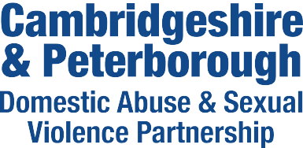

**Health IDVA Information for professionals**

***What is an IDVA?***

An IDVA (Independent Domestic Violence Advisor) works with current victims of domestic abuse to:



* + identify and assess risks
  + understand and access options
  + devise bespoke safety plans
  + navigate criminal and civil justice processes

They have an in-depth understanding of the dynamics of domestic abuse, including the impact on victim/survivors and the tactics and behaviours of perpetrators. They provide practical advice and emotional support to victim/survivors of domestic abuse, acting as their advocate when needed.

***What is a Health IDVA?***

Health IDVAs provide a specialist service working with all community and, hospital-based Health services across Cambridgeshire only (not Peterborough).

The team accepts referrals at all risk levels where there is current domestic abuse or separation in the last 3 months following a relationship where the victim was subjected to abuse. Referrals must be from professionals.

They can also provide advice and information to professionals.

# *What is a MARAC?*

MARAC is a multi-agency risk assessment conference to review the highest risk DA cases. The referral forms can be downloaded from our website under the ‘Professionals’ section:

## <http://www.cambsdasv.org.uk/>

.

**IDVAs can help with**

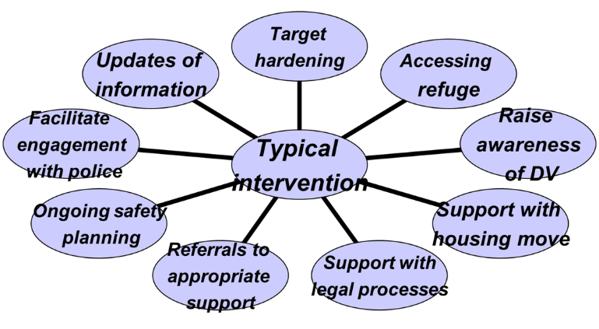

**To contact the Health IDVA:**



Please contact the Health IDVA on:

Mobile 07713 919229

## or email [idvacambs@nhs.net](mailto:idvacambs@nhs.net)