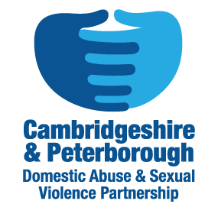
Professionals Leaflet for Cambridgeshire Young Person’s Domestic Violence Advisor
Professionals leaflet not be handed to potential clients
Purpose of Young People’s IDVA role:
- To provide support and safeguarding advice to young people in an abusive intimate relationship.
- To identify immediate risks and implement safeguarding measures to address crisis and reduce risk of harm.
- To regularly review risks and devise together bespoke safety and support plans.

How do we engage with young people?
- The YP IDVAs work peripatetically across Cambridgeshire with young people in places that are safe and convenient for them.
- We work with young people to develop safety plans with them and to encourage positive choices and actions for that young person.

Who is appropriate to be referred?
- Victims aged between 13-19 years, who are or have been in an intimate relationship with a partner whose behaviour is frightening, violent or abusive in any way.
- Young people suffering emotional, controlling or coercive behaviour by a partner or ex-partner.
- Young people aged 19-24 who have a diagnosed learning or physical disability or mental health issue.
- Young people aged 19-24 who are an ex ‘looked after child.’

NB: The young person needs to consent to the referral and want support. We are a voluntary service.

Other support YP IDVAs can offer:
- Advice and information to professionals who may be concerned about a young person.
- Professional consultation may be provided by the YP IDVA when appropriate

To contact Young People’s IDVA:
If you have any concerns about a young person, please contact the YP IDVA on IDVA.Referrals@cambridgeshire.gov.uk
Referral Pathway- http://www.cambsdasv.org.uk/website/children_and_young_people_/96818

